CHAPTER 1
INTRODUCTION
Waste Management is an idea where we can control lots of problem which disturbs the society in pollution and diseases. The waste management has to be done instantly else it leads to irregular management which will have adverse effect on nature. The Smart waste management is compatible mainly with concept of smart cities. The main objectives of our proposed system are as follows:
- Monitoring the waste management.
- Providing a smart technology for waste system.
- Avoiding human intervention.
- Resulting in healthy and waste ridden environment.
- Reward will be given to the user who throw waste in the Bin.

1.1. INTRODUCTION TO REWARD WIN BIN
According to a survey conducted by the govt of India, the main reason for the incessant growth of waste volumes in our urban centres is as a result of the ignorance of some dwellers towards the effect of indiscriminate dumping of refuse and the care free attitude of most of the dwellers, who know what should be done but they are careless about it.... this is supported by saying that everybody wants their refuse to be taken away, nobody wants to take part in its disposal and management. People lack interest towards the management of the refuse they generate. Although waste is generated by people, they show no concern towards its final disposal. This poor attitude may also be ascribed to the environmental protection agencies.
Most times people pack their waste in dustbins for weeks without the agencies coming
to evacuate them to the final point of disposition. As a result most people resort to
pouring dirt recklessly on the streets.
Characteristics of Reward Win Bin:
1. Monitoring the waste management.
2. Providing a smart technology for waste system.
3. Avoiding human intervention.
4. Reducing human time and effort.
5. Resulting in healthy and waste ridden environment.
This project falls under the category of embedded systems and android applications.
1.2. COMPONENTS OF SYSTEM
(a)Sensored Waste Bins
For Biodegradable and Non-Biodegradable waste management, there are two different bins in the system. These Bins has been installed with IR sensor at Different side which can detect the waste level of bin and send the notice to report department when these bins are full. Reward will be given by what the waste that has been entered in these bins and capacitive sensor will detect what is the density and weight of the bin that is being put in the bin.We also plan and send optimized routes directly to your drivers. Over-filling and emergency call outs become just a bad memory, while huge savings on driver hours, truck wear, and fuel costs are realised.For Smart Cities and municipalities in particular, your citizens enjoy a world class waste management service, see less trucks cluttering up our roads and don’t have to worry about needless noise or air pollution.
(b)Software Application
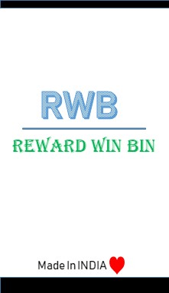
Figure 1.1 REWARD WIN BIN
Software App. is a comprehensive logistics solution that saves time, money and the environment. It uses wireless sensors to measure and forecast the fill-level of waste containers and generates smart collection plans using the most efficient schedules and routes. This solution provides up to 50% in direct cost savings. Receive automatically generated schedules and optimised routes which take into account an extensive set of parameters future fill level projections, truck availability, traffic information, road restrictions, container and content types the vehicle can collect etc. New schedules and routes are planned not only looking at the current situation, but considering the future outlook as well.
(C)Embedded System
Since both hardware and software both are introduced in this we need to maintain the server for the best route .Server also maintains that the value of the reward that is to be given to the user for the waste whether biodegradable or non biodegradable. Servers that provide data storage and data-mining solutions, ensuring the development of a Decision Support System (DSS). The DSS should be adaptable to the different operative contexts and should be able to extract consistent data from the database, in order to optimize the solid waste management process.

1.3. APPLICATIONS

The applications for RWB may be varied, but typically involve some kind of monitoring, tracking, controlling, and environment.

(a)Environment
- Reducing The Cost-Besides the environmental benefits of waste management, it is also beneficial to health as well. In the past, burning waste in the landfill or in the backyard was a common practice. But according to health agencies, when garbage and plastics are being burned, they produce particulate matter that are solid compounds and are suspended in the air. Exposure to this can increase the risks of developing heart disease, respiratory disease, asthma and emphysema. Proper disposal of waste or waste management relocates waste to areas where they can be left, incinerated or disposed of in a safe manner. Removing waste from public areas helps reduce risks to overall health, decreases exposure to biohazards and reduces infestation of pest.
- Reduce The Risk On Your Health-There is another advantage of proper waste management that not so many people are aware about and it is in the form of waste energy. Waste energy is basically a derivative of some techniques of waste management. Although incineration releases large amounts of carbon dioxide as well as other pollutants, modern advances have been available to capture the energy being produced in incineration and utilize it to generate electricity. The end result is an intricate method of reusing items to reduce the need of future waste. Though this is done on small scale by factories, it is a great start and is a huge benefit of waste management and disposal.

(b)Tracking
RWB will keep a trace of the route and will provide the smallest route to the transport department incharge to collect the waste and by this tracking it will ensure that no fuel is wasted as selecting the best route for the collection.

(c)Controlling
Controlled waste is waste that is subject to legislative control in either its handling or its disposal.As a legal term, Controlled waste applies exclusively to the UK but the concept is enshrined in laws of many other countries. The types of waste covered includes domestic, commercial and industrial waste. They are regulated because of their toxicity, their hazardous nature or their capability to do harm to human health or the environment either now or at some time in the future. A prime concern is the effects of biodegradation or biochemical degradation and the by-products produced.

CHAPTER 2

LITERATURE SURVEY
  - INTRODUCTION
In India there is no proper waste management .There are large number of steps that have been taken till now to work or fight against the waste all across the world. India doesn’t want to be a step back on in any case that relates to waste management, there are several steps taken daily. But the main or whole point is that it doesn’t affect the people for a large amount of time, or hold up other for thinking about taking an initiative towards cleanness.

  - DATA GATHERING
In an ideal waste management system there should be proper reduce,reuse,recycle,proper decomposition processes which can help in the betterment of the environment. There were many movement or plans that initiated by either govt. Or my the people who are indulge in waste management system.
    - SWACHH BHARAT ABHIYAN

The campaign was officially launched on 2 October 2014 at Rajghat, New Delhi by Prime Minister Narendra Modi. It is India's largest cleanliness drive to date with 3 million government employees, school students, and college students from all parts of India participating in 4,041 statutory cities, towns and associated rural areas. Modi has called the campaign "Satyagraha se Swachhagrah" in reference to Gandhi's “Champaran Satyagraha” launched on 10 April 1917.

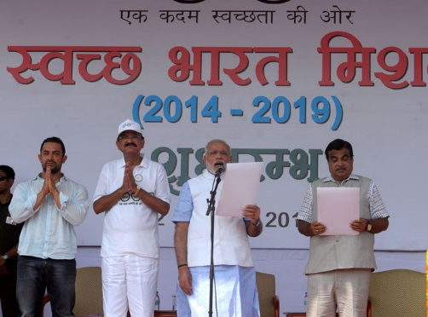
Figure 2.1 Swachh Bharat Abhiyan

    - SMART TRASH BINS
Automatic open-close lid for ease of use and to avoid physical contact, so no germs transmission . Dry Wet garbage separation .Warning message sent to garbage collector when bin gets full.This bin only does the purpose of collecting the waste, there is no separation or different section for different type of waste. It only sends notification when bin get full.sends notification when bin gets full.

    - GARBAGE BINS THAT OFFER FREE WIFI TO USER

Smart bin that was created by Prateek Agarwal and Raj Desai, this bin gives user reward in the form of WIFI. This smart bin contain only one section for all type of waste. This project doesn’t get implemented correctly or doesn’t stay valuable in market for a long period of time. As developer of this project say “ We need to work more or come with something new in this so it goes well”.

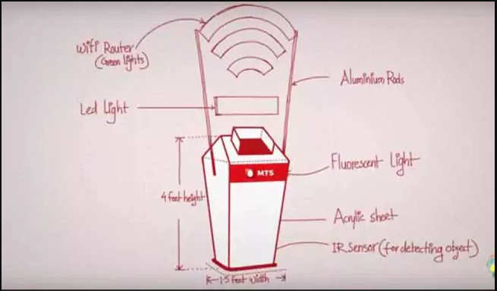
Figure 2.2 WIFI reward to users

CHAPTER 3

THE PROPOSAL/ METHODOLOGY

  - INTRODUCTION

User throw waste in bin and the sensor generate value according to the waste
and store in the QR Code through which the user can add the value in his reward account in user Application. On the other side when bin gets full the location send to the Transport Application .
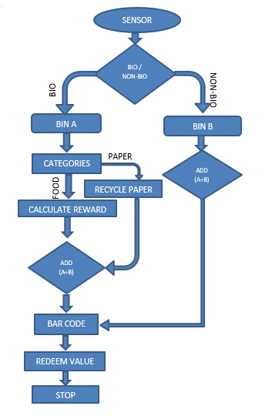
Figure 3.1 Flowchart

CHAPTER 4
SIMULATION RESULTS AND ANALYSIS
4.1 SOFTWARE ENVIRONMENT

In the case of software Reward Win Bin have two android applications one of them is “QR code generation application” and second one is “User andTransport Application”

    - QR CODE GENERATION APPLICATION
In the QR Code Generation Application in which QR Code is generated on the bases of the value which will generate on throw the waste in the bin Either it is Biodegradable or Non-Biodegradablebin. by getting the value from the hardware this app will generate the QR Code to redeem the reward value of the waste and store in wallet of user. The working and coding of this application is as below:

      - Create Android Application Project
Open android studio go to New > New Project.
Application name “QRGenertionRWB”
Company name “rewardbinwin.com”
Project location “where u want to store the app files”
Then Click “Next”
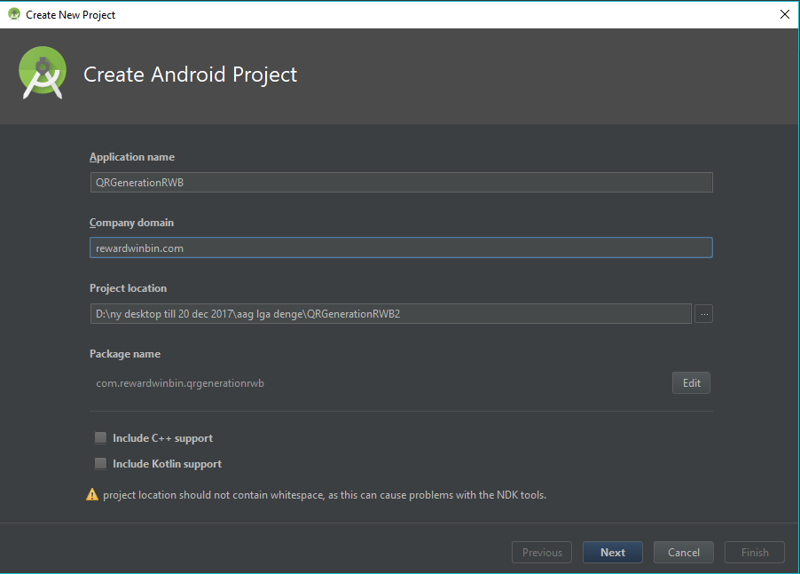
Figure 4.1 Create Android Project

4.1.1.2 Minimum Version of Application
In this we select the minimum sdk version of android application from which this application will install and run .

Check “Phone & Tablet “
Select “API 21: Android 5.0 (Lollipop)”

Click “Next”
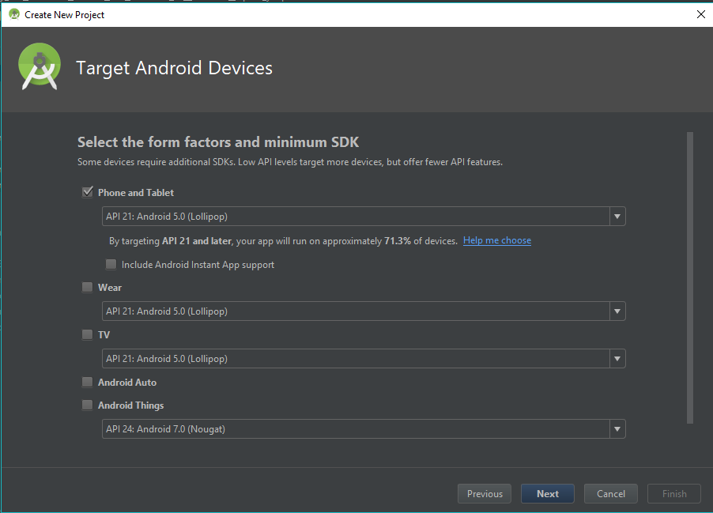
Figure 4.2 Version of application

    - Select Activity
In this we select the Activity from which we want to start the development of android application
Select “Empty Activity”
Click “Next“
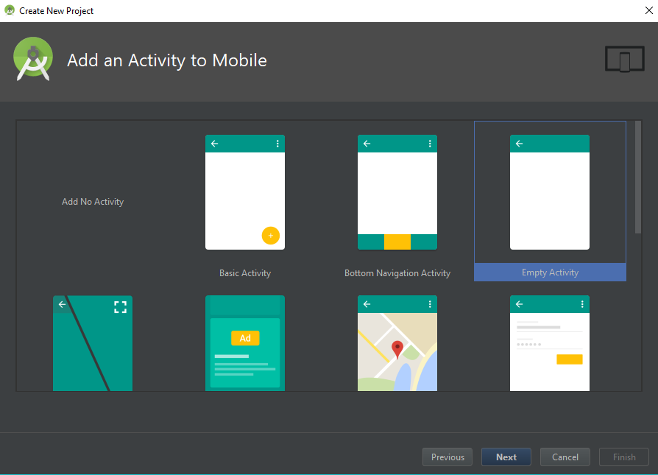
Figure 4.3 Select Activity

      - Files Structure
Structure of all the linked files in the android files.

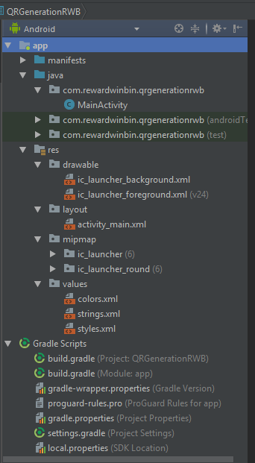
Figure 4.4 Files Structure
      - Add Library
In this we add libraries to add the external pre-made file to link in our project

implementation 'com.android.support.constraint:constraint-layout:1.0.2'
implementation 'com.journeyapps:zxing-android-embedded:3.2.0'
implementation 'com.google.zxing:core:3.2.1'

and Click ‘Sync now‘

      - Design of Application GUI

The Graphical User Interface if the Android Application is design on XML language and the design of code is as:

<?xml version="1.0" encoding="utf-8"?>
<LinearLayout xmlns:android="http://schemas.android.com/apk/res/android"
xmlns:app="http://schemas.android.com/apk/res-auto"
xmlns:tools="http://schemas.android.com/tools"
android:layout_width="match_parent"
android:layout_height="match_parent"
android:orientation="vertical"
tools:context=".MainActivity">

<TextView
android:layout_width="match_parent"
android:layout_height="wrap_content"
android:text="GENERATE QR CODE"
android:textColor="@color/Black"
android:textStyle="bold"
android:gravity="center"
android:layout_marginTop="20dp"
android:textSize="25sp"
android:fontFamily="monospace"/>
<LinearLayout
android:layout_width="match_parent"
android:layout_height="wrap_content"
android:orientation="horizontal"
android:gravity="center"
android:layout_marginTop="20dp">

<TextView
android:layout_width="wrap_content"
android:layout_height="wrap_content"
android:text="Value:- "
android:textAlignment="center"
android:layout_gravity="center"
android:textSize="20sp"
android:textStyle="normal"
android:textColor="@color/Black"/>

<EditText
android:layout_width="100dp"
android:layout_height="wrap_content"
android:layout_marginLeft="50dp"
android:id="@+id/valueqr"/>
</LinearLayout>
<LinearLayout
android:layout_width="match_parent"
android:layout_height="wrap_content"
android:orientation="vertical"
android:gravity="center"
android:layout_marginBottom="20dp">

<Button
android:layout_width="wrap_content"
android:layout_height="wrap_content"
android:text="Generate"
android:layout_marginTop="10dp"
android:paddingLeft="40dp"
android:paddingRight="40dp"
android:background="@color/colorPrimary"
android:textColor="@color/White"
android:textStyle="bold"
android:textSize="20sp"
android:id="@+id/gen_btn"/>
<ImageView
android:layout_width="230dp"
android:layout_height="230dp"
android:layout_marginTop="20dp"
android:id="@+id/qrcode"/>
</LinearLayout>

</LinearLayout>

      - Add Colors
In color.xml we add all the colors in this file which we use in the android application

<?xml version="1.0" encoding="utf-8"?>
<resources>
<color name="colorPrimary">#009432</color>
<color name="colorPrimaryDark">#303F9F</color>
<color name="colorAccent">#FF4081</color>
<color name="Black">#000</color>
<color name="White">#FFF</color>
</resources>
4.1.1.8 Add String
Add string to this string.xml to this file which we use in this project

<resources>
<string name="app_name">QR Generation RWB</string>
</resources>

4.1.1.9 Styles use in this project

In this styles.xml contain all the styles which we will us in this project and the main style is the main android appearance style

<resources>
<!-- Base application theme. -->
<style name="AppTheme" parent="Theme.AppCompat.Light.DarkActionBar">
<!-- Customize your theme here. -->
<item name="colorPrimary">@color/colorPrimary</item>
<item name="colorPrimaryDark">@color/colorPrimaryDark</item>
<item name="colorAccent">@color/colorAccent</item>
</style>

</resources>

      - Android Manifest File

In the android manifest file, we link all the activities if the project and also define the app name and the logo of the app there

<?xml version="1.0" encoding="utf-8"?>
<manifest xmlns:android="http://schemas.android.com/apk/res/android"
package="com.rewardwinbin.qrgenerationrwb">

<application
android:allowBackup="true"
android:icon="@mipmap/ic_launcher"
android:label="@string/app_name"
android:roundIcon="@mipmap/ic_launcher_round"
android:supportsRtl="true"
android:theme="@style/AppTheme">
<activity android:name=".MainActivity">
<intent-filter>
<action android:name="android.intent.action.MAIN" />

<category android:name="android.intent.category.LAUNCHER" />
</intent-filter>
</activity>
</application>

</manifest>

      - Graphical User Interface and Functionality

- Front UI of QRCodeGenerationRWB Application

The front UI of the application contain one EditText and one GENERATE Button to generate the QR Code by the value generated according to the waste throw in bins.

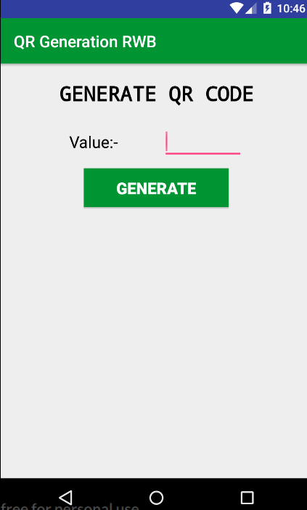
Figure 4.5 Generate QR Code

- Value in EditText

The value has to put in edit text to generate QR code that will scan from user application
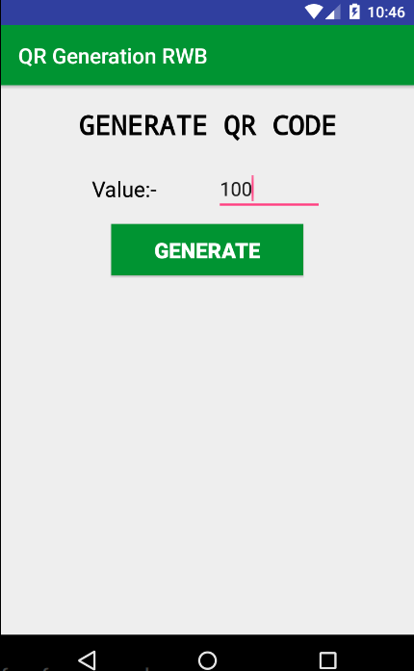
Figure 4.6 Inserting Value

- Generate QR code

Click on the GENERATE button to generate the QR code

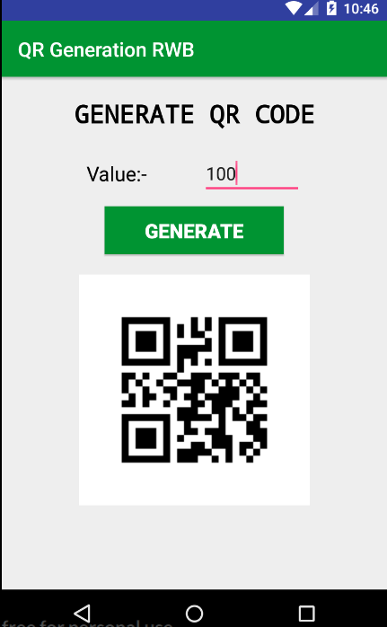
Figure 4.7 QR Code Generated

  - User & Transport Application

The user application is divided into two parts one is User and other one is Transport application. User app is used to generate scan the QR Code from the QR code generation application and that value from the code will store in the Wallet of the user and he/she can redeem that value to buy things or can also transfer to any E-Wallet like Paytm, etc. and in Transport application the location from the GPS module will show the full bin in the google map on the Transport Application and afterward app will show the shortest path toward full dustbin.

4.2.1 Project Creation
The procedure to create the project is as same as the QRGenerationRWB application.

4.2.2 File Structure

Structure of all the linked files in the android files.

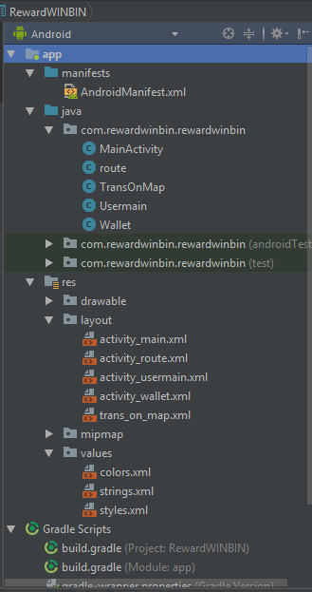
Figure 4.8 File Structure

4.2.3 Add Library

In this we add libraries to add the external pre-made file to link in our project

implementation 'com.journeyapps:zxing-android-embedded:3.2.0'
implementation 'com.google.zxing:core:3.2.1'
implementation 'com.google.android.gms:play-services-maps:12.0.0'

and Click ‘Sync now‘

    - Design of Application GUI

The Graphical User Interface if the Android Application is design on XML language and the design of code is as:

activity_main.xml

<?xml version="1.0" encoding="utf-8"?>
<LinearLayout xmlns:android="http://schemas.android.com/apk/res/android"
xmlns:app="http://schemas.android.com/apk/res-auto"
xmlns:tools="http://schemas.android.com/tools"
android:layout_width="match_parent"
android:layout_height="match_parent"
android:gravity="center"
android:orientation="vertical"
tools:context=".MainActivity"
android:background="@drawable/mainback">

<Button
android:layout_width="120dp"
android:layout_height="50dp"
android:layout_gravity="center"
android:text="User"
android:background="@color/colorPrimary"
android:textColor="#fff"
android:id="@+id/Btn_user"/>
<Button
android:layout_marginTop="50dp"
android:layout_width="120dp"
android:layout_height="50dp"
android:text="Transport"
android:background="@color/colorPrimary"
android:textColor="#fff"

android:id="@+id/btn_transport"/>

</LinearLayout>

activity_usermain.xml

<?xml version="1.0" encoding="utf-8"?>
<RelativeLayout xmlns:android="http://schemas.android.com/apk/res/android"
xmlns:app="http://schemas.android.com/apk/res-auto"
xmlns:tools="http://schemas.android.com/tools"
android:layout_width="match_parent"
android:layout_height="match_parent"
android:orientation="vertical"
tools:context=".Usermain">

<TextView
android:id="@+id/scantv"
android:layout_width="match_parent"
android:layout_height="wrap_content"
android:layout_alignParentStart="true"
android:layout_alignParentTop="true"
android:layout_marginTop="130dp"
android:gravity="center"
android:text="Scan QR CODE"
android:textColor="@color/Black"
android:textSize="30dp" />

<Button
android:layout_width="wrap_content"
android:layout_height="wrap_content"
android:layout_alignParentBottom="true"
android:layout_centerHorizontal="true"
android:layout_marginBottom="218dp"
android:gravity="center"
android:text="Scan"
android:textSize="25dp"
android:id="@+id/scanid"
android:paddingTop="10dp"
android:paddingRight="50dp"
android:paddingLeft="50dp"
android:paddingBottom="10dp"
android:background="@color/colorPrimary"
android:textColor="@color/White"/>

</RelativeLayout>

activity_wallet.xml

<?xml version="1.0" encoding="utf-8"?>
<RelativeLayout xmlns:android="http://schemas.android.com/apk/res/android"
xmlns:app="http://schemas.android.com/apk/res-auto"
xmlns:tools="http://schemas.android.com/tools"
android:layout_width="match_parent"
android:layout_height="match_parent"
tools:context=".Wallet"
android:background="@drawable/walletback">

<TextView
android:id="@+id/textView"
android:layout_width="202dp"
android:layout_height="wrap_content"
android:layout_alignParentTop="true"
android:layout_centerHorizontal="true"
android:layout_marginTop="23dp"
android:fontFamily="monospace"
android:text="Wallet"
android:textColor="@color/Black"
android:textSize="30sp"
android:textAlignment="center"/>

<TextView
android:layout_width="wrap_content"
android:layout_height="wrap_content"
android:layout_alignParentTop="true"
android:layout_centerHorizontal="true"
android:layout_marginTop="167dp"
android:text="Amount"
android:textColor="@color/Black"
android:textSize="35sp" />

<ImageView
android:id="@+id/rupee"
android:layout_width="35dp"
android:layout_height="46dp"
android:layout_alignParentBottom="true"
android:layout_alignParentStart="true"
android:layout_marginBottom="199dp"
android:layout_marginStart="135dp"
android:src="@drawable/rupee" />

<TextView
android:id="@+id/amountid"
android:layout_width="wrap_content"
android:layout_height="wrap_content"
android:layout_alignParentEnd="true"
android:layout_alignTop="@+id/rupee"
android:layout_marginEnd="121dp"
android:text="0"
android:textColor="@color/Black"
android:textSize="35sp" />

</RelativeLayout>

trans_on_map.xml

<?xml version="1.0" encoding="utf-8"?>
<LinearLayout xmlns:android="http://schemas.android.com/apk/res/android"
xmlns:app="http://schemas.android.com/apk/res-auto"
xmlns:tools="http://schemas.android.com/tools"
android:layout_width="match_parent"
android:layout_height="match_parent"
tools:context=".TransOnMap">
<ImageView
android:layout_width="match_parent"
android:layout_height="match_parent"
android:src="@drawable/map_preview"
android:id="@+id/map_preview"/>

</LinearLayout>

Activity_route.xml

<?xml version="1.0" encoding="utf-8"?>
<android.support.constraint.ConstraintLayout xmlns:android="http://schemas.android.com/apk/res/android"
xmlns:app="http://schemas.android.com/apk/res-auto"
xmlns:tools="http://schemas.android.com/tools"
android:layout_width="match_parent"
android:layout_height="match_parent"
tools:context=".route">
<ImageView
android:layout_width="match_parent"
android:layout_height="match_parent"
android:src="@drawable/route"/>
</android.support.constraint.ConstraintLayout>

    - Graphical User Interface and Functionality

- Front UI of the U&T Application

The front UI of the application contains two button one is for user and other one is transport.

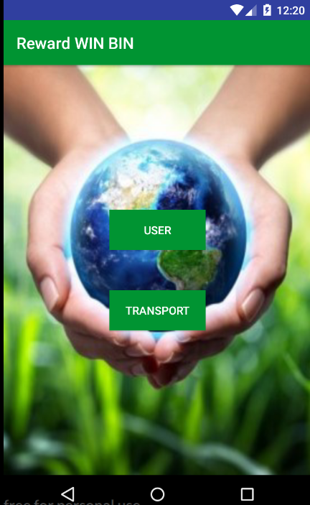
Figure 4.9 Applicaton UI

- User Interface

On click on the user button that sent to the next activity which is for scan the QR Code from the QRGenerationRWB application.

Click ‘ SCAN’
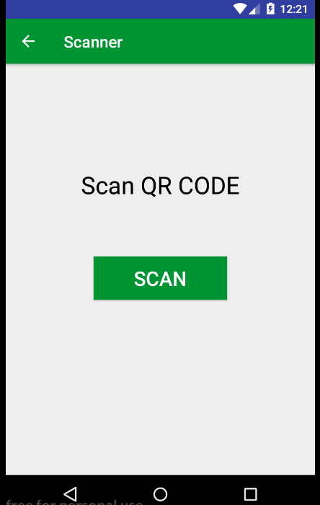
Figure 4.10 Scan QR Code

- Scanner Interface

This is the interface through which we can scan the code using our mobile phone camera.

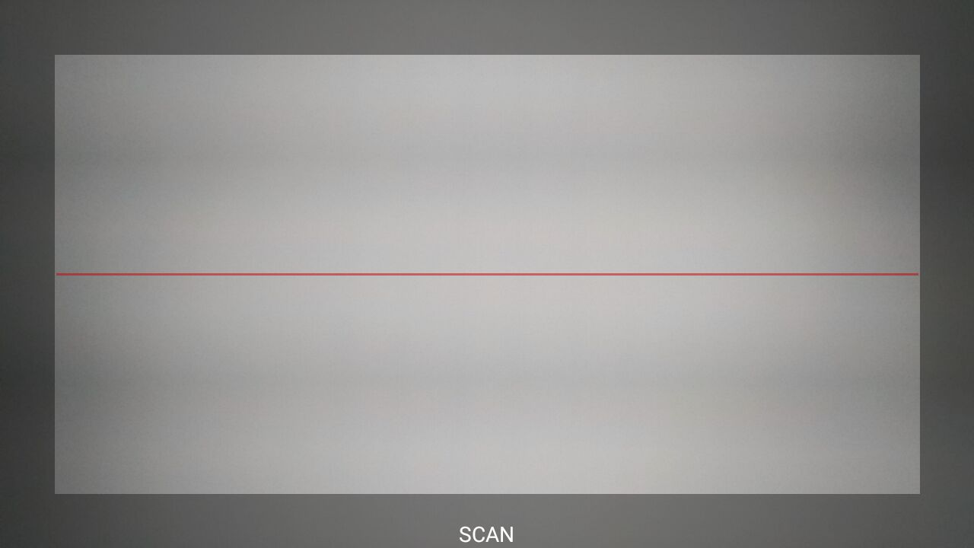
Figure 4.11 Scanning

- Wallet Interface

After scanning the reward QR code the value of the reward will store in the wallet.
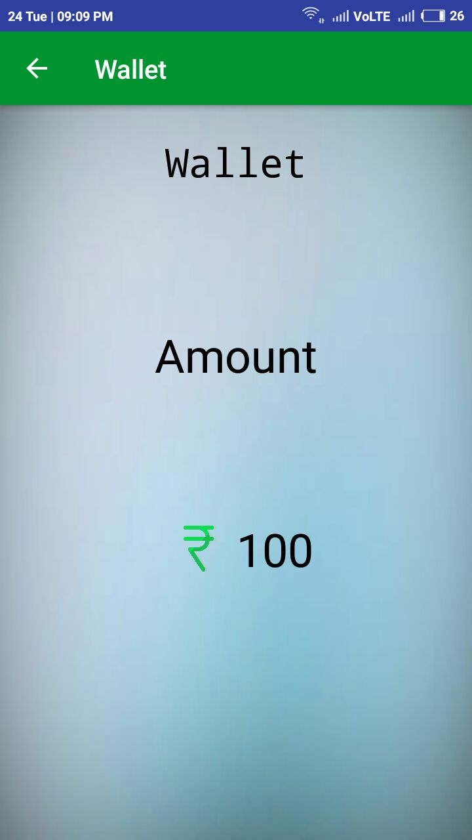
Figure 4.12 Amount

- Transport Application Interface

In the transport application, the location of the full dustbin will send on the transport application to driver.

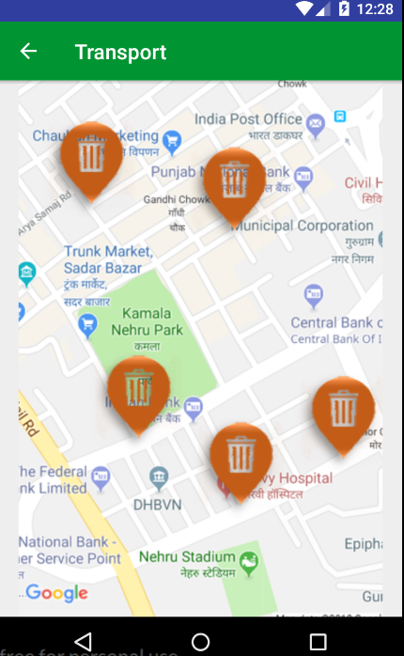
Figure 4.13 Transport Department

Short Route toward Destination

On selecting one dustbin by driver the find the shortest route to ward the destination.

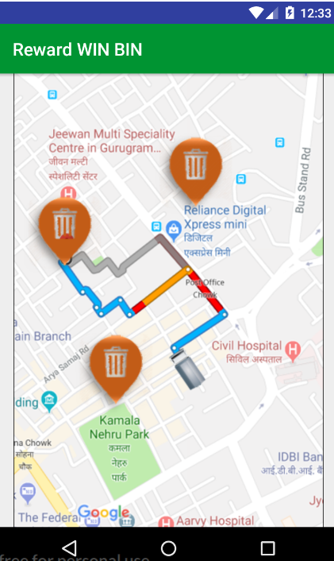
Figure 4.14 Selecting Shortest Route

  - HARDWARE ENVIRONMENT

4.3.1 WORKING
Reward Win- Bin is an embedded system. It has both hardware & software integration. the software part consists of android mobile application . the application is divided into 2 parts one is User Application other is Transport Application. User application manages the account of user and also used for reward. transport application is used for Collection of waste from Bins.
Reward Win Bin is a two division bin, both installed with distance measurement sensor, GSM and GPS will notify the coordinate and bin status to the database. Here GSM is user to communicate with the server, which will contain the SIM with the basic speed internet. The ultrasonic sensor which uses ultrasonic waves will check the bin status. The PIC controller board is used to control ultrasonic sensor, GSM and GPS.

The server will maintain the details of the unfilled bins, filled bins and authority registration. Whenever the normal user or authorized bin collect or request from the database the information will be given to them. The information to the normal user is about the nearest unfilled bin and authorized person will be given the coordinated of the filled bins. Whenever the user will put some of the waste in the reward bin he/she will be benefitted with a reward that can be used afterward at various places.

The user end will contain the android app which works on android compatible phone. There will be two separate buttons for user and authority. The user will notify the unfilled nearest bin with path and authorized person will be notified by the filled bins with path. The working is as follows, User inserts trash into the bin, and gets a reward point from the bin using this app and then the Bin checks for threshold level, Bin sends the status and coordinates to the Control centre on reaching the appropriate level, Control centre uses the coordinates sent by multiple Bins and provides an optimal path to the garbage vehicle, The bin if emptied by the vehicle, a notification is sent by it to Control centre. This helps in easy monitoring. This process is only applicable for non biodegradable waste that can be reused or retransform to form new thing that can be used for manufacturing good. in case of biodegradable waste that waste will directly get converted in fertilizers using appropriate process which can be sent to market at a very cheap rate and can be used by farmers for farming and also it will reduce the extra cost that is provided by govt of India at various stances. Reward point can be made using a login id so that the point stored can be used for major use.The First sensor is used for detection of user. Microcontroller. the then its go through the relay.

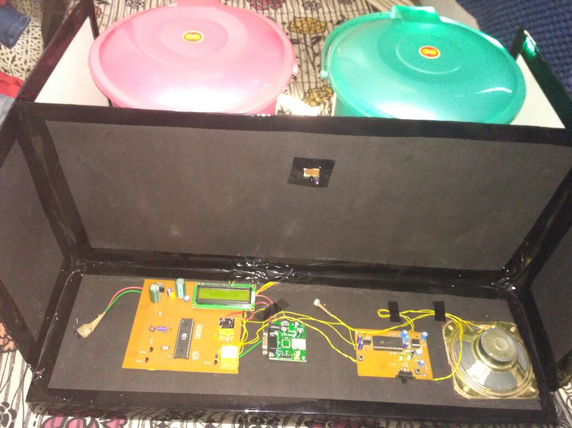
Figure 4.15 Hardware Implementation

4.3.2 COMPONENTS

- IR Sensor
Three IR sensors is mounted on both dustbins at the top. it will detects the level of dust when it detects the level of dust LED light will automatically glow, output of the sensor will counted in the binary format or Boolean format. IR sensor will consist of emitter and detector and related circuit. It is whole set of (IR LED) IR Sensors work by using a specific light sensor to detect a select light wavelength in the Infra-Red (IR) spectrum. By using an LED which produces light at the same wavelength as what the sensor is looking for, you can look at the intensity of the received light. When an object is close to the sensor, the light from the LED bounces off the object and into the light sensor. This results in a large jump in the intensity, which we already know can be detected using a threshold.

- GSM Module
Global System for mobile this module will use for sending messages to Transport department from where to collect the waste. GSM modem duly interfaced to the MC through the level shifter IC Max232. The SIM card which is mounted GSM modem upon receiving digit command by SMS from any cell phone send that data to the MC through serial communication. Once the program is executed, the GSM modem receives command ‘STOP’ to develop an output at the MC, the contact point of which are used to disable the ignition switch. The command so sent by the user is basically based on an intimation received by him through the GSM modem.

(c)Frame Relay
Frame relay service supports permanent virtual circuits (PVCs). PVCs require network administrative setup at subscription time. Frame Relay provides bandwidth-on-demand and, by providing multiple virtual circuits per physical access port, reduces the connection access cost and customer investment in equipment.This frame-switching protocol is optimized for modern reliable digital and fiber-optic transmission networks. Frame Relay is also an effective way to optimize bandwidth, consolidate networks, and do multiprotocol bridging and routing. Because of the high-speed requirement and the highly reliable transmission media, Frame Relay protocol design has very little protocol overhead .Because acknowledgment and retransmission requirements are eliminated, the internodal processing and its associated delay are minimized. NetWare Link/Frame Relay leaves it up to the higher-level protocols at the end-user devices to ensure reliable end-to-end data transfer. Because of this, Frame Relay requires both reliable transmission media and higher-level protocols to operate efficiently and reliably.

(d)Microprocessor 8086
Microprocessor 8086 has the gps coding done. Microcontroller can be considered a self-contained system with a processor, memory and peripherals and can be used as an embedded system.The majority of microcontrollers in use today are embedded in other machinery, such as automobiles, telephones, appliances, and peripherals for computer systems.
While some embedded systems are very sophisticated, many have minimal requirements for memory and program length, with no operating system, and low software complexity. Typical input and output devices include switches, relays, LED's, and sensors for data such weight,density etc. Embedded systems usually have no keyboard, screen, disks, printers, or other recognizable I/O devices of a personal computer, and may lack human interaction devices of any kind
(e)Speaker
When the IR Sensor detect the person standing near the bins ,it will generate a message ”THROW BIODEGRADABLE WASTE IN BIN 1 AND NON BIODEGRADABLE WASTE IN BIN 2” through speaker. Speaker also tells the human to distinguish in the type of waste.

(f)Microcontroller
A microcontroller is a small computer on a single integrated circuit Microcontrollers are designed for embedded applications, in contrast to the microprocessors used in personal computers or other general purpose applications consisting of various discrete chips.
Microcontrollers are used in automatically controlled products and devices, such as automobile engine control systems, implantable medical devices, remote controls, office machines, appliances, power tools, toys and other embedded systems. By reducing the size and cost compared to a design that uses a separate microprocessor, memory, and input/output devices, microcontrollers make it economical to digitally control even more devices and processes. Mixed signal microcontrollers are common, integrating analog components needed to control non-digital electronic systems.
(g) GPS Module
A GPS navigation device, GPS receiver, or simply GPS is a device that is capable of receiving information from GPS satellites and then to calculate the device's geographical position. Using suitable software, the device may display the position on a map, and it may offer directions.

CHAPTER 5

CONCLUSION AND FUTURE SCOPE

  - CONCLUSION
Over all we interpret that REWARD WIN BIN is a smart bin project which has several key points which can help in managing waste in a systematic or in proper manner.

Sensored Bins are used for Biodegradable and Non-Biodegradable waste management, there are two different bins in the system. These Bins has been installed with IR sensor at Different side which can detect the waste level of bin and send the notice to report department when these bins are full. Reward will be given by what the waste that has been entered in these bins and capacitive sensor will detect what is the density and weight of the bin that is being put in the bin. We also plan and send optimized routes directly to your drivers. Over-filling and emergency call outs become just a bad memory, while huge savings on driver hours, truck wear, and fuel costs are realised. For Smart Cities and municipalities in particular, your citizens enjoy a world class waste management service, see less trucks cluttering up our roads and don’t have to worry about needless noise or air pollution.

Software Application consists of User Application and Transport Applicatipon.User Application handles database of each user. This app is the main key of this project, whenever a user throws a garbage in bin it will generate a QR code, which a user scanned by this app and can redeem its point. This app is also linked to other platform where they can transfer or use this reward points.Transport Application is used by only those who is used to pick waste. Bin after sense that it is full, there is something to do. So this done or solve this purpose. Access to this application is given by administrator only.
Embedded System concludes both software or hardware part in it. Both plays essential role in making it a solution to waste management.Since both hardware and software both are introduced in this we need to maintain the server for the best route.Server also maintains that the value of the reward that is to be given to the user for the waste whether biodegradable or non-biodegradable. Servers that provide data storage and data-mining solutions, ensuring the development of a Decision Support System (DSS). The DSS should be adaptable to the different operative contexts and should be able to extract consistent data from the database, in order to optimize the solid waste management process.

  - FUTURE SCOPE

- Change the system of user’s authentication and atomic lock of bins which would help in securing the bin from any kind of damage or theft.
- Improving graphical interfaces for the Server and complete Android applications has possibility of extending the system adding other use cases and applications for smart cities.
- We can also use Wi-Fi and Ethernet components, In place of GSM Module.
- Bio-Degradable waste that collect are used to prepare fertilizer from them. So a large amount of natural fertilizer can have made at cheap cost, then the cost at which fertilizer is now available at the market.
- Technology that automatically sense that waste is bio & non-bio can be implement, which reduces the risk of mixing the waste.
- Database of a user need to be completely safe, so we can take measure to secure a complete database.
- Smart Trash Bin can be used in Colleges/University Campus, Shopping malls, Railway stations.

REFERENCES
- Narayan T. 2008 Municipal solid waste management in India: from waste disposal to recovery of resources?Waste Manage. 29, 1163–1166.
- Biswas AK, Kumar S, Babu SS, Bhattacharyya JK, Chakrabarti T. 2010 Studies on environmental quality in and around municipal solid waste dumpsite. Resour. Conserv. Recycling 55, 129–134.
- Ministry of Environment and Forests (moef). 2015 The Gazette of India. Municipal solid waste (Management and Handling) rules, New Delhi, India.
- Rana PR, Yadav D,Ayub S, Siddiqui AA. 2014 Status and challenges in solid waste management: a case study of Aligarh city. J. Civil Eng. Environ. Technol. 1, 19–24.
- Sharholy M, Ahmed K, Mahmood G, Trivedi RC. 2008 Municipal solid waste management in Indian cities: a review. Waste Manage. 28, 459–476.
- Gupta S, Krishna M, Prasad RK, Gupta S, Kansal A. 1998 Solid waste management in India: options and opportunities. Resour. Conserv. Recycling 24, 137–154.
- Khajuria A, Matsui T, Machimura T, Morioka T. 2010 Assessment of the challenge of sustainable recycling of municipal solid waste management in India. Int. J. Environ. Technol. Manage. 13, 171–187.

